If you want to showcase a unique invention story
如果你想展现独特的发明故事
我的发明日志
My invention Log
（使用提示： 如果你想要记载发明故事和过程，可以自由使用本日志页面记录，见证你的 发明过程。例如：在发明过程中做出了什么行动、行动的方式方法、以及行动的结果 … … 这些内容可能包括图纸、计算、描述、测试结果等。如果你想放入视频，可以将视频链接 地址或二维码放在空白页上。这些页面可以自由增加页数。）
(Usage Tip: If you wish to document invention stories and processes, feel free to use this journal
page to record and witness your invention journey. For instance, actions taken during the invention process, methods employed, and the outcomes of these actions……These contents may include
drawings, calculations, descriptions, test results, etc. If you wish to include a video, you can place the video link address or QR code on a blank page. You are free to add pages as needed.)
日期Date 1/29/2024

Today, I first learned how to use electronics, and how to use Arduino. After downloading Arduino, I first started on how to control the basic electronic components. Controlling the electronic components is relatively easy. First, I need to connect the electronic component to my Arduino board using wires and confirm a connection in the virtual layer. Once the connection is created, I can start controlling the electronic component. Using functions digitalWrite and analogWrite, I can then send the directions to the electronic component.
Once I learned how to control the electronic component, I started on a mini project: building a car. I first started on building the hardware of the car, involving two wheels, two motors, battery, switch, frame of the car, Arduino board, and infrared ray receiver and sender. Some were glued on the board. Others are attached to intentional clip left on frame. After some work, the car is done. I immediately started on coding the software. I started on building 5 functions to control the car to go forward, backward, left, right, and stop.
Then, using the infrared ray receiver and sender, I can control the car. Except it that the buttons seem to have a lot of delay, which is not fun.

我的发明日志 如果你想展现独特的发明故事

My invention log

日期Date 1/30

If you want to showcase a unique invention story

Forgetting about the infrared receiver and sender, I turned to an ultrasonic sensor. This ultrasonic sensor supposedly will use ultrasound to detect the distance between itself and a wall. Its function of ultrasonic sensor is supposedly to avoid obstacles. Yet, the process involves unacceptable delays and failing to turn that I do not understand what happened. I tried to fix these bugs, but the best my car can do is to crash into a wall, and turn after 1 second, then crash into another wall. These bugs just exists forever, even after changing the motor (because I think that it is the motor’s problem.
日期Date 1/31

Since I am planning to create a bionic leg, I will need to plan my leg using Solidworks, an application that can create 3D models. AutoCAD is an 2D drawing tool, which can help me master Solidworks faster. Today is just a day which I draw lines, create shapes, and cut the shapes out to form an easy mobile phone holder. Quite an easy day indeed.

我的发明日志 如果你想展现独特的发明故事

My invention log

日期Date 2/1

If you want to showcase a unique invention story

Today is the day which I learned Solidworks, an essential tool for my modeling. Solidworks is like AutoCAD. I just need to choose a plane, draw my 2D design, and add a depth to it. It is simple if you learned AutoCAD before.
After I learned all the basic skills of the project, I finally can start to begin my project, which starts on 3.17.

我的发明日志 如果你想展现独特的发明故事

My invention log

日期Date 3/17

If you want to showcase a unique invention story

To first started to plan my creation of the bionic leg. Using Solidworks, I started to map out my parts of the bionic leg. I first started to map out the drive leg. The drive leg is where the motor of the bionic leg is at. I need to create the motor-axle machine that will move the foot of the ankle. I need to map out the dimensions of the supporting boards, motors, axles, and other parts that make up the drive leg.
For the bionic ankle, I will want the statistics to be as close to a real human ankle.
An average human calf is around 500mm. So, for the drive leg, I estimated it to be a length of 250mm. The drive legs are the place to put two motors, so it cannot be too short in length.
I first need to design two boards that can fix the motors. To make work easy, the two boards are set to be identical. There will be two parts of the board: the motor part, where a motor is attached to this side, and the axle part, where the axle is attached to it. The first board's motor will correspond to the second board's axle. The first board's axle will correspond to the second board's motor.
The motor has a diameter of 89mm. I estimated that I need 10 mm of spacing between the motors for it to not interfere. There also need some space at the top of the board for connection to top boards and bottom boards. After calculation, the motor’s center is set to be 65.5 mm away from the top of the board. To protect the motor, I also designed a circular baffle on the board to cover the motor. This circular baffle has a radius of 47.5mm, which covers the motor’s 89 mm diameter. Additionally, a small hole must be at present for the motor’s external DIP switch, which is used to control the ID of the motor. Moreover, on the other end of the sideboard, there must be a hole for the axle, which is set for 19mm.
The top boards and bottom boards of the drive leg are different. Both boards need to have a support for the guide wheels, an L-shaped structure with a hole to put in the guide wheels.
The top board is used to connect with the upper leg (either another machine or human upper leg). There is no additional structure on the top of the leg. The upper leg is as follows.

我的发明日志 如果你想展现独特的发明故事

My invention log

日期Date 3/24

If you want to showcase a unique invention story

Today, I plan to model out the bottom part of the leg, which consists of the supporting leg and the foot.
The lower part of the leg is at first a cylinder, but I need to attach a connector and spring system to the leg, so I changed the bottom to a rectangular block. I then drew the connector and spring’s dimensions (they are bought parts) and fit them onto the leg.
Then, I copied the dimensions of the universal joint to Solidworks. The universal joint it going to connect the connector leg with the foot. The universal joint is a mechanical component that allows two-dimensional movement, similarly to the ankle’s movement. It contains three parts: upper Yolk, a block, and lower Yolk.
The foot is a rectangle shaped with a semicircle on top of it. There are two structures that are used to attach the tension springs, but now, it is not connected to it.
Overall, after the end of 3.24, the bionic ankle looks like this.
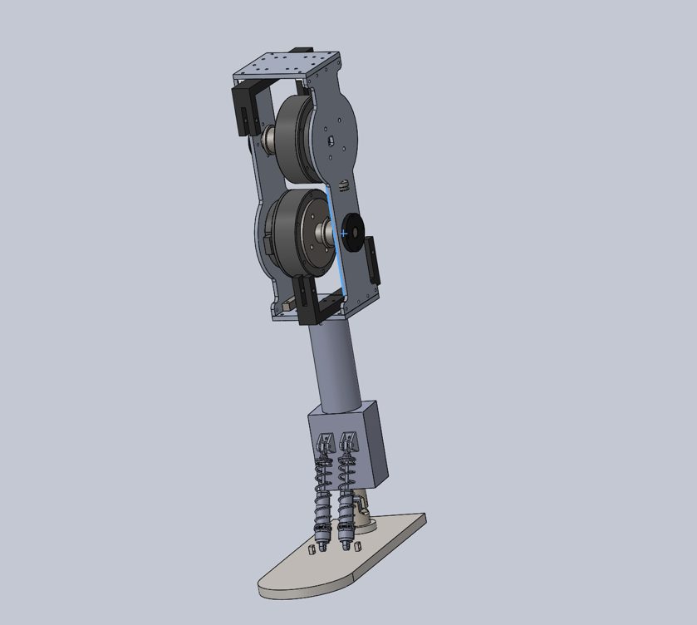

The main framework of the bionic ankle is done, but there are still large rooms for improvements.

我的发明日志 如果你想展现独特的发明故事

My invention log

日期Date 3/31

If you want to showcase a unique invention story

Today, I did the final touches to my first version of the model. For the supporting leg, I added a pair of tension springs that pulls on the springs mentioned above. This will allow a right-left movement for the leg. Also, the leg is redesigned to make it more like a foot, with an increased depth and smooth curves on it. There is also four holes on the corner such that strings can be fixed on here.
The guide wheel supporter has an additional triangular structure so that it’s strength is enough
Then, I added all the screws that connects the whole structure together, and check if there are any adjustments needed to make. For four special screws, an additional cut into the supporting leg is needed to attach the supporting leg and the drive leg together. Also, the connection between the tension spring and spring is calculated such that the screw head will not interfere with the supporting leg.
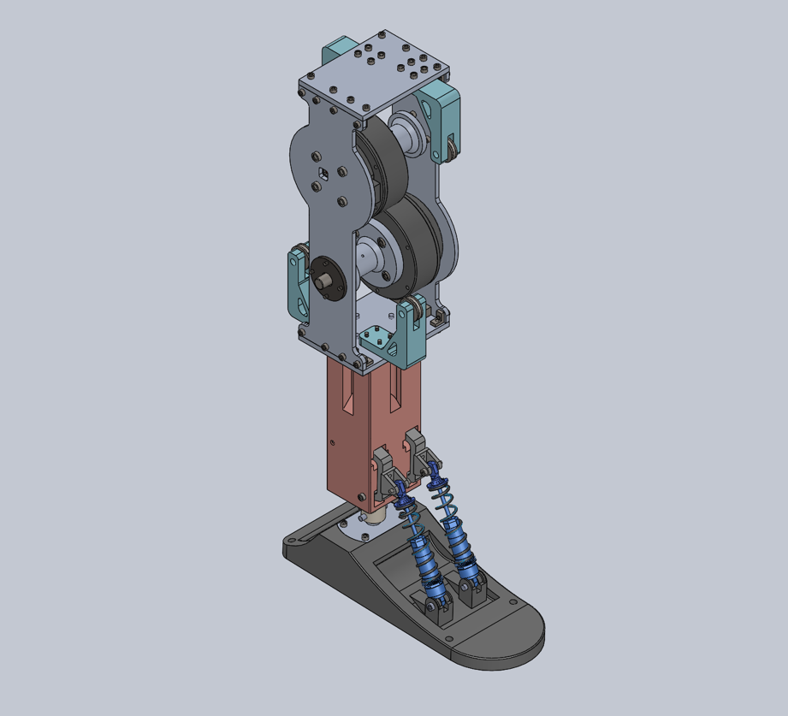
This is the diagram after the adjustments.

我的发明日志 如果你想展现独特的发明故事

My invention log

日期Date 4/5

If you want to showcase a unique invention story

Today, I started to build my first version of the bionic ankle.
I first started the foot. I need to connect the foot with the universal joint. Using screws to work a screw thread into the 3D printed material, I was able to connect them all together. The next part is to connect the universal joint to the supporting leg, which again involves screwing through 3D printed material. After that, I started to build the spring system in the supporting leg. The tension spring is connected to the leg and the connector. The connector part is then connected to the spring, and finally the spring is connected to the foot. Through all of this, the leg can finally stand on its own, and move 2 dimensionally.
After finishing the supporting leg and the foot, I started to work on the drive leg. I first started on connecting the upper and bottom board with the guide wheel supporter and the guide wheel. Then, I started to build the axle and motor system. I put the motor and the axle on one piece of board, and then, put the other one on top of the motor and axle. Then, I used some more connectors to connect the upper and lower board. Finally, the whole drive leg is completed.
To connect the drive leg with the supporting leg, I must screw in the four screws through the tiny trenches. The tiny trenches are so small such that the screwdriver cannot fit into it. Screwing these four screws are tedious work.
With the screwing finally done, the whole bionic leg is finished except for the string system. I need to bind the string on the four corners of the leg.
After the building process, I played with the leg for a bit, and the universal joint connector broke. In therefore need to design a new connector that can withstand more force.
But these are for the next day I work on this project.

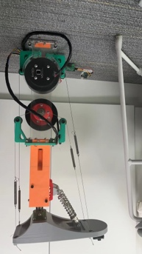

我的发明日志 如果你想展现独特的发明故事

My invention log

日期Date 4/19

If you want to showcase a unique invention story

The string binding plan is suspended, as I need to check the functions of the motor. If the strings are bind onto the foot, it is easy to break the whole ankle if some coding goes wrong.
For the motor, I choose three functions: send, stop, and read. Send function can direct the motor to move to a certain angle. Stop function can stop what the motor is doing. Read function can read the angle of the motor.
The read function is the hardest of all, as there are two motors. Each motor will send its data to my computer, ruining each other’s signals. The only way to save this seems to be adding delays to the function, but it is still not fixed completely.
After making sure that the three functions are safe, we fastened up the strings, and tested it. Fastening the strings are not an easy job. I need a lot of strength to pull it and find a good way to attach it the legs. I don’t have a good method to tie a knot or something. It took a lot of time.
After finishing up with the strings, I still managed to break the foot. The place on the foot that relates to the spring broke, which means I need to print the foot. This is the second time when a 3D printed structure broke. This also means that I need to bond the string again.
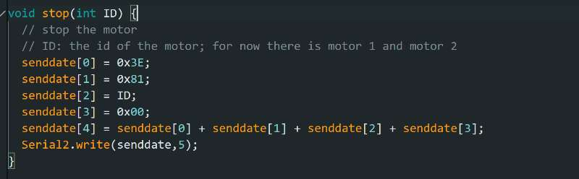
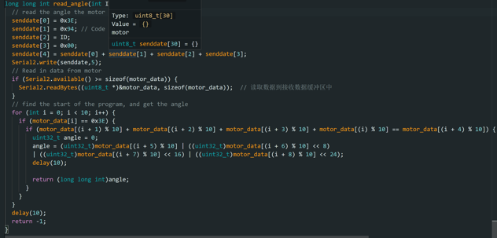
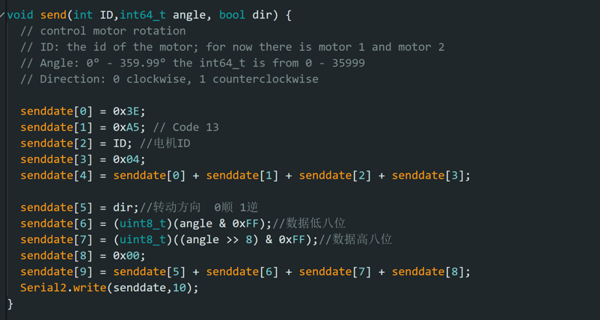
After some more playing and testing with the bionic ankle, I found out some problems that I need to solve in the next version. There must be a way to tighten the strings with the axle, reducing the power loss due to the sliding of the string. The string also needs new ways to fasten onto the ankle, because it is very hard to make it tight. The motor also vibrates a lot, meaning I need to add something to decrease the vibration.

我的发明日志 如果你想展现独特的发明故事

My invention log

日期Date 5/5

If you want to showcase a unique invention story

In this day, I found some better ways to fasten the string, using some string fastening parts, I was able to connect the strings better and faster to the foot. I need to change the holes on the foot of course, but problems in modifying the foot is much easier to deal with.
After the binding of the strings are finished once and for all, I turned to the electronics, which I build up the whole system with Arduino board NANO. I also found new ways to control the foot. There is an increment function in the motor, which will work with moving the foot better than directing the motor to spin to the stated angle.
The increment function is also failing me. The motor just would not move for some reasons I do not understand. I do not even understand how I fixed the problem. I just rewrote the function and it worked for some reason.
Although I was using NANO, but I found out I need a remote-control board to receive data from a planned gyroscope that will be embedded on the bottom of the leg. Using a wire to connect the two will mess up the wiring. So, I changed to esp32, which have a great remote-control function. It also have TX and RX pins on the hardware, therefore not needing virtual basis of TX, RX connection.

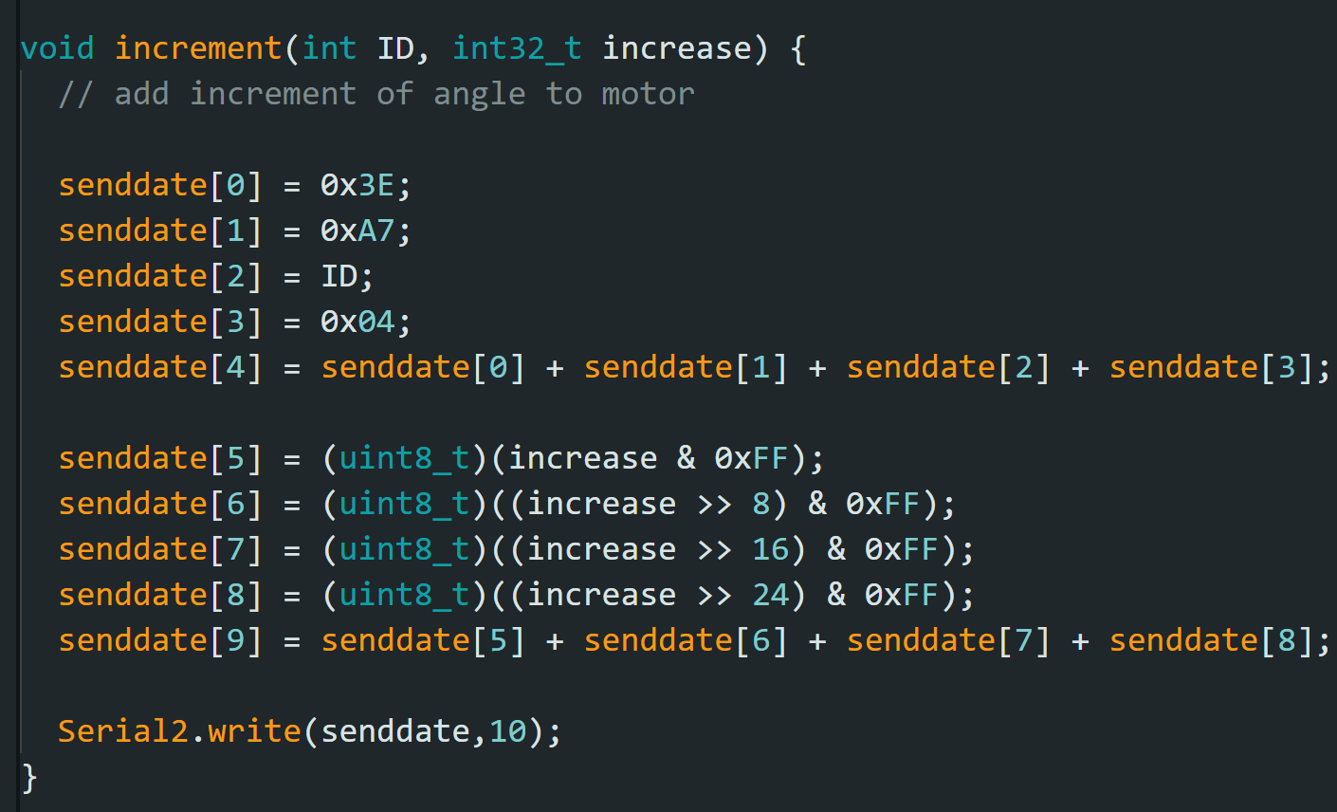

我的发明日志 如果你想展现独特的发明故事

My invention log

日期Date 5/12

If you want to showcase a unique invention story

With the increment function at hand, I started to work on the actual algorithm: PID. Proportional – integral – derivative controller, or PID controller, is a control loop mechanism that calculates the error from the desired values and the process variable and uses proportional, integral, and derivative terms to minimizes the error. The PID controller needs tedious debugging work to get right the variables.
I first tried an easy PID controller using a small motor, but the gyroscope is not stable enough to use PID controller. This mini project was halted sadly.

日期Date 5/19

The morning of 5/19, I kept on adjusting my PID controller, but it constantly broke, and I must keep hold of the ankle to stop it breaking itself.
The afternoon of 5/19 involves learning new application: ADAMS. ADAMS is a strong physics simulator. It can model objects, forces acting on objects, joints between objects, cable systems, and more. ADAMS is a strong tool to help on understanding how the foot moves. I learned how ADAMS can import files from Solidworks, set the joints, add forces and cable systems. Using these functions, I can model my whole bionic ankle into ADAMS. Working on it, I deleted every screw and unnecessary objects to decrease the memory needed to load the model and added joints to make it function like the real one.
The work is still not done yet. There is still a cable system that I have not added onto the ADAMS model, and I need MATLAB to work with it.

\

我的发明日志 如果你想展现独特的发明故事

My invention log

日期Date 5/26

If you want to showcase a unique invention story

MATLAB is a strong mathematics tools that can work with ADAMS. Aside from its powerful ability to draw graphs, it has the possibility to simulate electronics system. Connecting it with ADAMS, MATLAB can control the forces of ADAMS and receive information from it. These means that the whole electronics system can be inputted into it.
I first practiced my MATLAB skills. First, I build a simple seesaw in ADAMS, and try to control a small ball on top of it. I connected it with MATLAB, and build a simple PID controller to control the torque on the seesaw. I then fiddled with the constants in the PID. The ball keeps flying off the seesaw with my numbers. But, at last, I managed to get one that looks fine and stable.
I look to the day where I can simulate the bionic ankle in ADAMS.

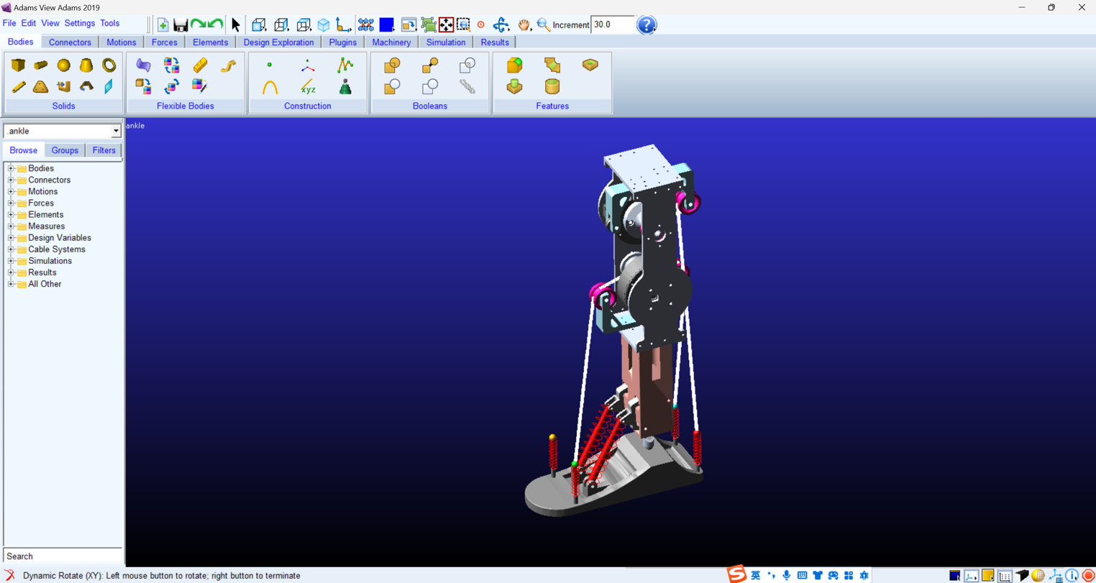
我的发明日志 如果你想展现独特的发明故事

My invention log

日期Date 7/3

If you want to showcase a unique invention story

I tested the foot using a simulate block as the ground. The block is 3D printed, and I stuffed an esp32 and a IMU to transmit the “ground” pitch and roll to the central esp32. This will be improvised into distance sensors.
For now, I set the actual pitch and roll to try to be as close to the ground’s pitch and roll, creating the input for the PID controller built. During the test, the motors constantly turned the foot in the wrong direction, which involved a great risk in breaking the ankle.
Overall, the PID controller looks find, and the foot can follow the ground well. It is fun to rotate the block and see how the foot is going to move. For the foot not to break, I set a maximum and minimum for the foot to turn.

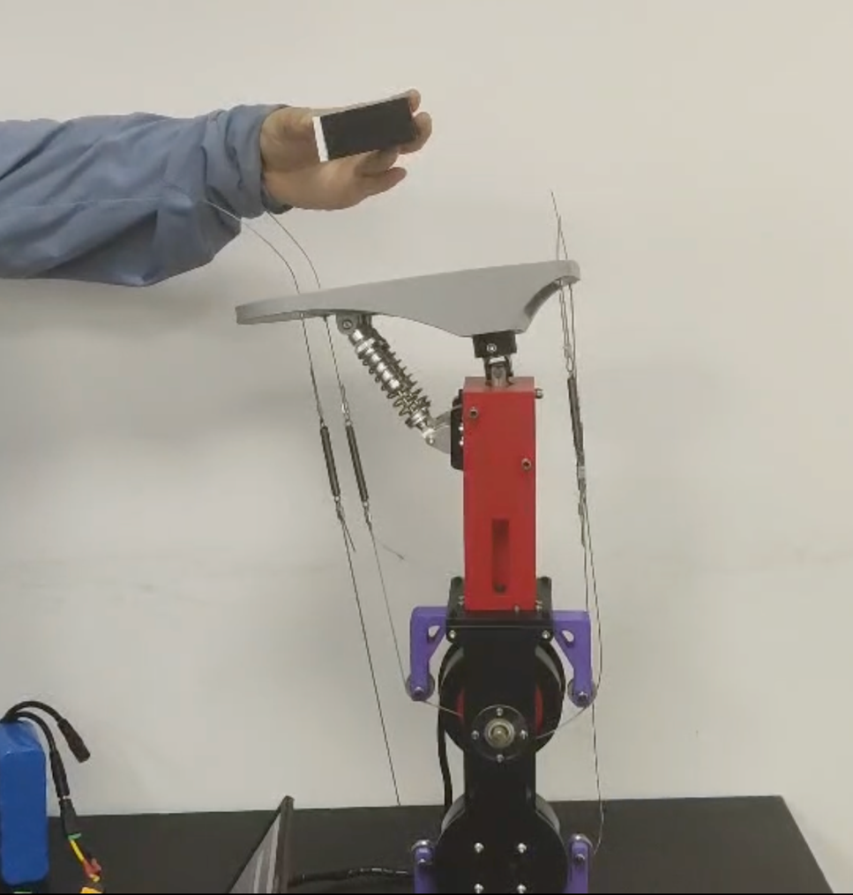

我的发明日志 如果你想展现独特的发明故事

My invention log

日期Date 7/4

If you want to showcase a unique invention story

I updated my bionic ankle into materials that will not break easily. After receiving some metal parts, I started to dismantle my first version of the bionic ankle, gathered useful parts, such as the universal joint, the foot, and the motors. I changed the boards mostly into metallic ones. This will make the whole structure more durable, such that the universal joint connector will not break easily. During this involves re tying the strings once again, which proved to be very tiring even with the improved methods.
I also did an experiment to determine the maximum angle that the ankle can reach, and it matches with human ankle’s angles.
After done with reconstructing the bionic ankle, I retested the the ability to self-adapt with the ground. It worked just fine.

我的发明日志 如果你想展现独特的发明故事

My invention log

日期Date 7/5-8

If you want to showcase a unique invention story

The following days I prepared for ICC, on all materials. Mainly the poster.
I took new pictures of the 2nd version and updated some experiments and word on the poster.

我的发明日志 如果你想展现独特的发明故事

My invention log

日期Date 7/16

If you want to showcase a unique invention story

After finishing with ICC, I started to improvise the detector mechanism that the foot is supposed to have. This day I implemented the distance sensor version of the foot, making it able to find the ground on its own. The VL53L0X, although it says to be accurate, but is affected greatly by light, the texture of the surface, and other different things.

I first used a board to simulate what will happen when I put it on the foot. On the board, I embedded the four VL53L0X on the board, placed the esp32 and a switch to manipulate the signals given. At the esp32, I used simple trigonometry to calculate the angle.
After testing out, the result looks not that pleasant. So, I decided to combine data to create a smoother curve. If the pitch and roll given to the foot is constantly changing, the foot will constantly move and jerk in weird directions. However, this will decrease the speed in which the foot reacts to a change in the inclination. But, The smooth curve prevails.
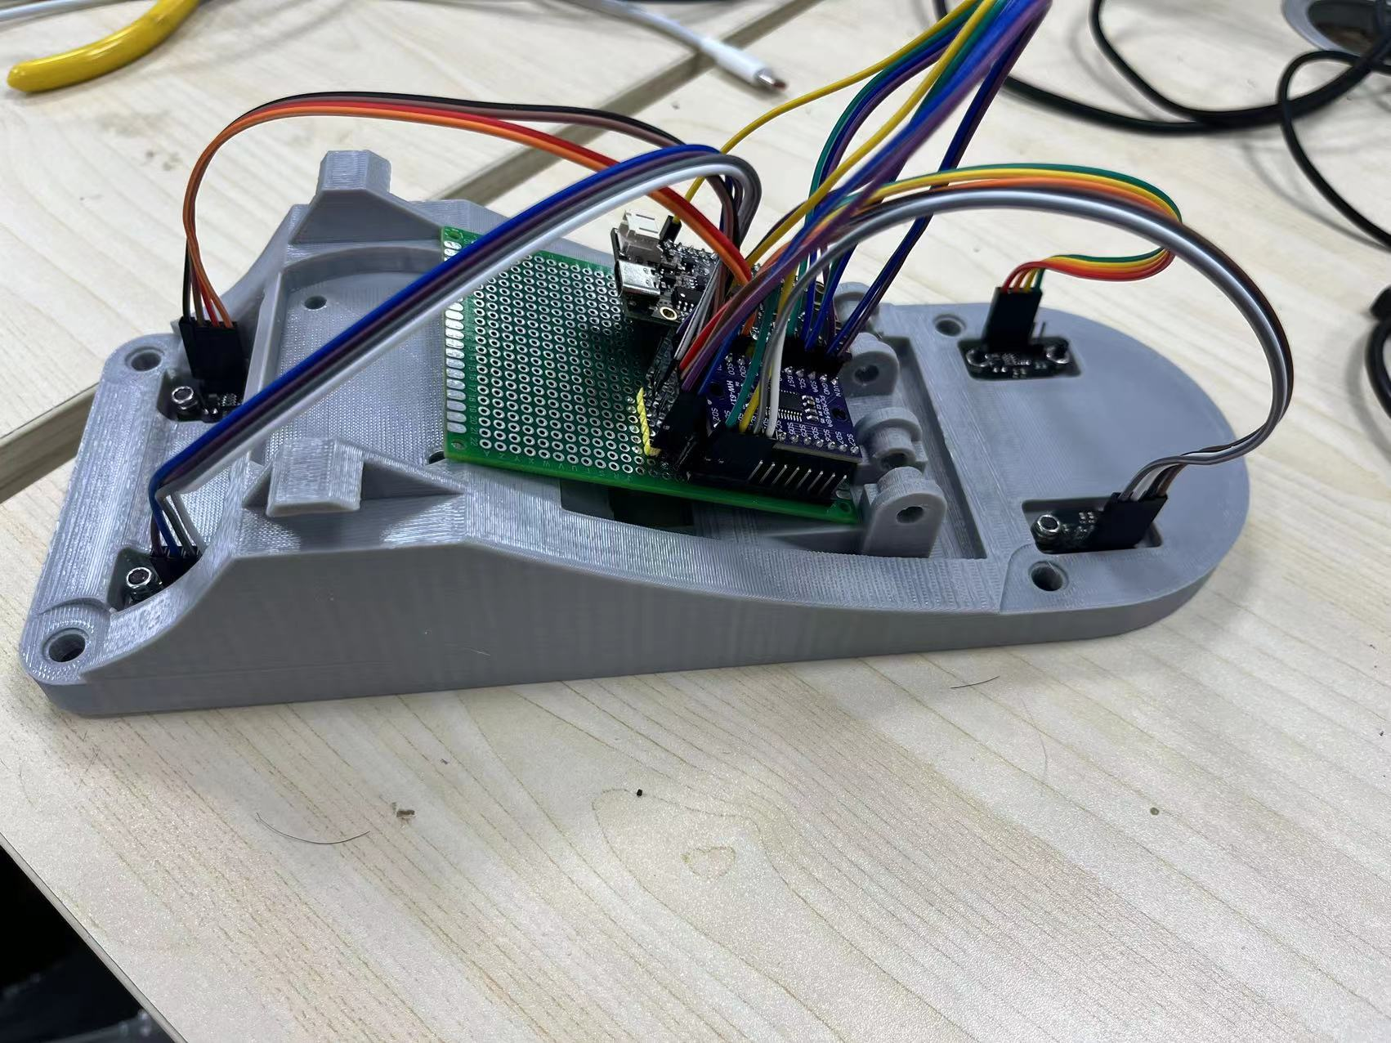
我的发明日志 如果你想展现独特的发明故事

My invention log

日期Date 7/17

If you want to showcase a unique invention story

After testing the distance sensors with a board, it is time to run it on the foot. I 3D-printed another version of the foot. Took a long time to screw the original out and fix the new one up. The problem with the distance sensors is there is no space on the foot. The small space for the IMU is no longer possible. I must put it on top of the foot, and with all the lines connecting to the switch, it is not pleasant.
I spent the afternoon finishing of the whole process. 3D printing is a long process

我的发明日志 如果你想展现独特的发明故事

My invention log

日期Date 8/2

If you want to showcase a unique invention story

After finishing the process, I tested out how it can follow the ground and find that the foot keeps jerking. SO I increased the number of data combined to make the foot less sensitive to the weird numbers that the distance sensors are producing. I don’t find the decrease in the reaction a big problem, as it turns out to be quite the same for the human eye.
Playing with the bionic ankle, I realized that I should keep the foot in the right direction. I almost broke it when I am doing it, since the code is implanted for the upside-own direction. Risking a lot, I changed the code according to what have happened to the foot. Of course, also with some common sense on predicting how the foot will move.
Yet the foot have grown heavy, and lifting it with bare hands is not a good option.
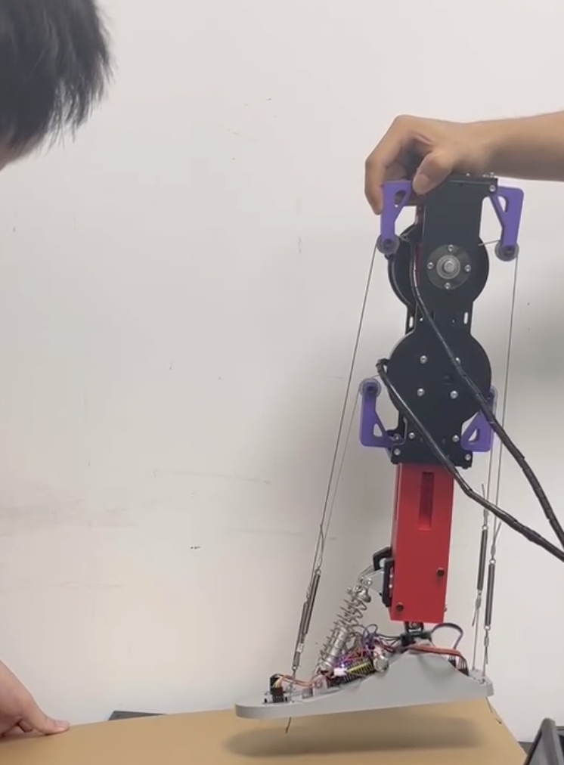
我的发明日志 如果你想展现独特的发明故事

My invention log

日期Date 8/10

If you want to showcase a unique invention story

I started the design how the frame will look like. In my idea, it is going to look like this:

The frame lifts the foot some distance of the ground, and it have two motors controlling its turn and a motor controlling is vertical distance. Of course, a motor is not the best option. A putter and some sliders to do it.
In my first version however, I just implemented the putter to turn the angle of the foot.

我的发明日志 如果你想展现独特的发明故事

My invention log

日期Date 8/11

If you want to showcase a unique invention story

This day I started to build the frame, cutting out pieces, and connecting them together using the connector pieces preplanned by the pieces, after build the frame, 3D printed materials such as the axle is implanted onto the top of the frame. The foot is swinging below the axle, such that when moving the axle, the whole machine can move. The putter is connected to the top of the axle. When it shrinks or extend, it will push the top of the axle and turn the ankle.
Controlling the putter requires a thing to switch the flow of the current, which can be done by two switchers. After constructing all of this, the day is practically done.

我的发明日志 如果你想展现独特的发明故事

My invention log

日期Date 9/7

If you want to showcase a unique invention story

After testing the speed and the angular displacement that the putter should do, I decided that the putter should swing in a loop. I designed an uneven terrain, showing the inclination of the ground, and how the foot is moving through the ground.
Using flexible, boards, I bend them with an angle to show that the foot can adapt to the different inclinations. I filmed a video about this change in the process.
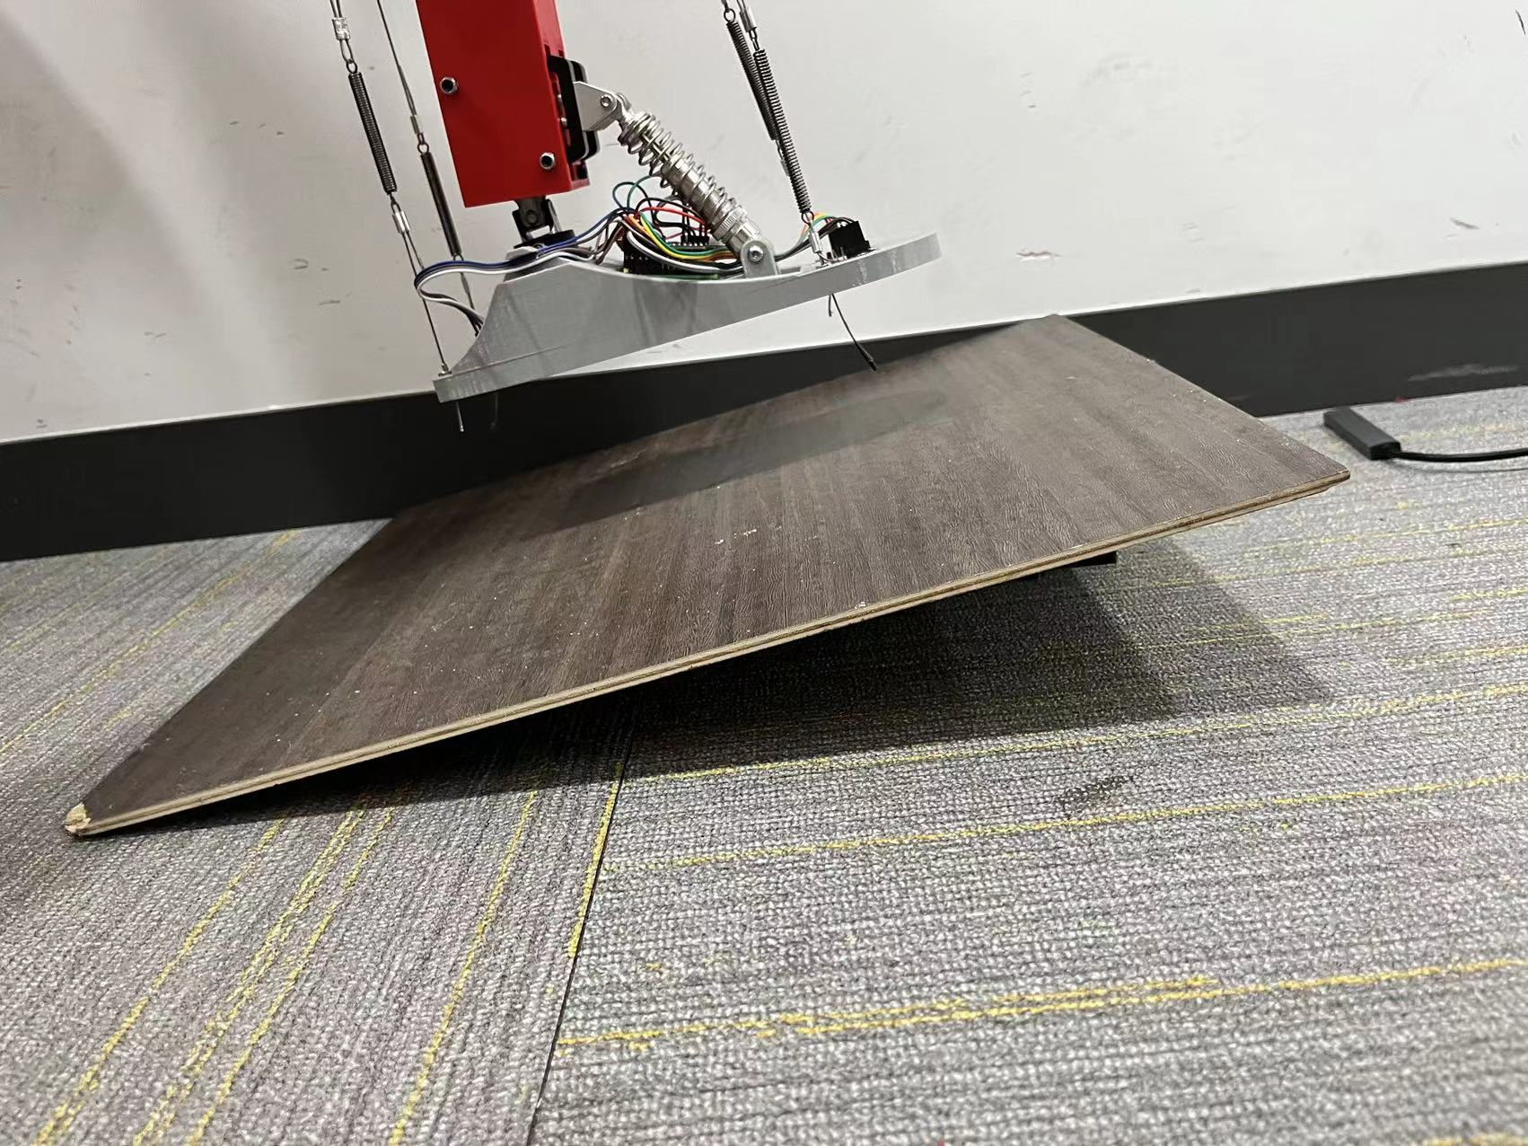
我的发明日志 如果你想展现独特的发明故事

My invention log

日期Date 9/21

If you want to showcase a unique invention story

After done with the version framework which can only turn, I started to reconstruct the whole frame to incorporate the slider. The slider needs to be pointed upward, which will cause instability to the whole structure, so there must be two parts to connect the structure to the frame, and two poles for it to leans on.
I started to redesign the frame to Solid works such that all the requirements can be fulfilled. The axle must be changed, as when it is 90° flipped, some of the parts is going to interfere with the foot.

我的发明日志 如果你想展现独特的发明故事

My invention log

日期Date 10/5

If you want to showcase a unique invention story

Today I continued to work on the frame. Adding all the structure mentioned on the previous diary is not an easy task. I first reworked the frame, adding new poles to support the sliders. Then, I used the small connectors to connect them to other poles, gradually forming the basis. After putting the slider on, I added the two triangular connectors and the wheel and axle onto the slider, forming the frame 2.0.
The next move is to control the slider. I used the code copied form online has the basis and used the functions to move the slider. After doing all this, I found that the up and down of the sliders will allow the foot to swing, so I must use a Bluetooth to control the structure by hand.
After all of this, I turned to film the performance of the ankle on a rough surface. Using flexible boards, I build an uneven terrain for the bionic ankle to test upon.
Then, I started to film the whole ankle. In the middle of the process, the ankle accidently crashed onto the frame, breaking the guide wheel support. So this experiment must postpone some days.
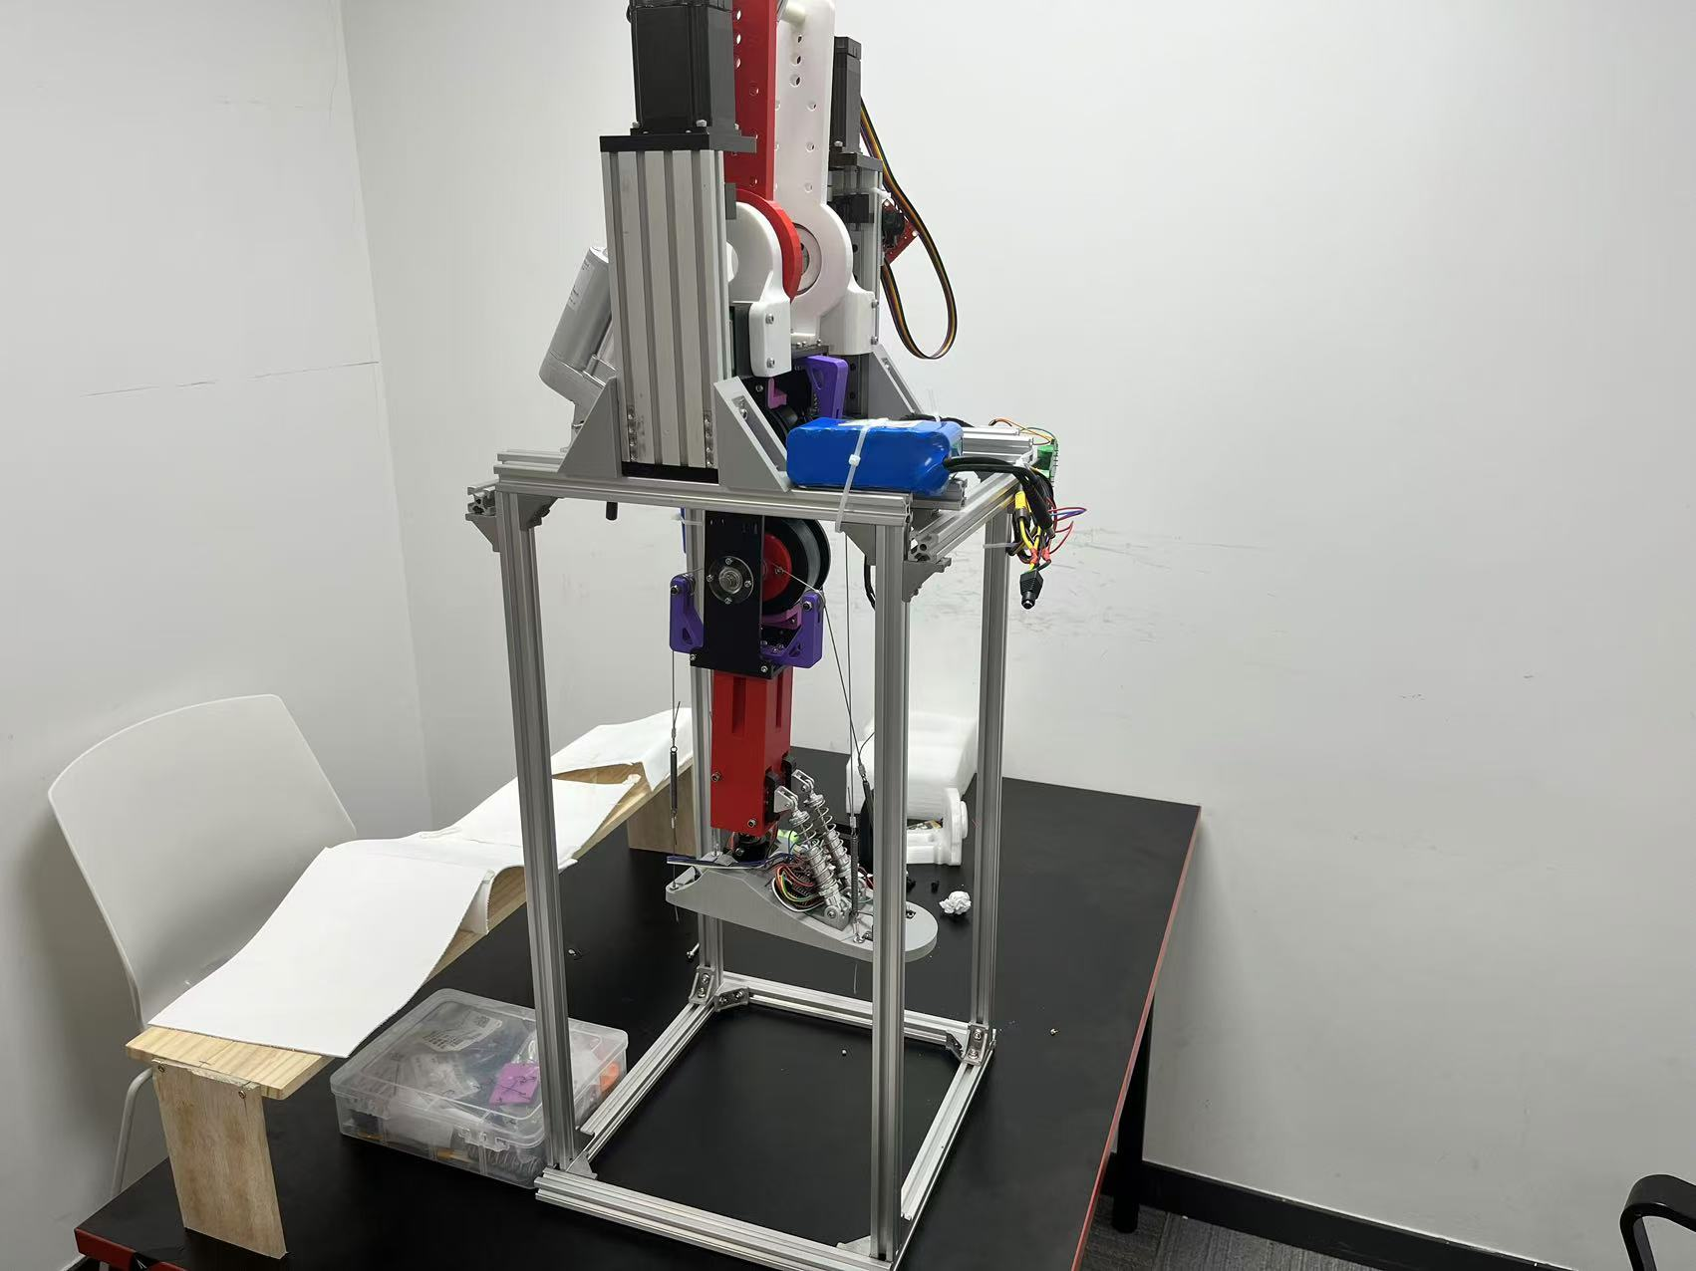

我的发明日志 如果你想展现独特的发明故事

My invention log

日期Date 10/19

If you want to showcase a unique invention story

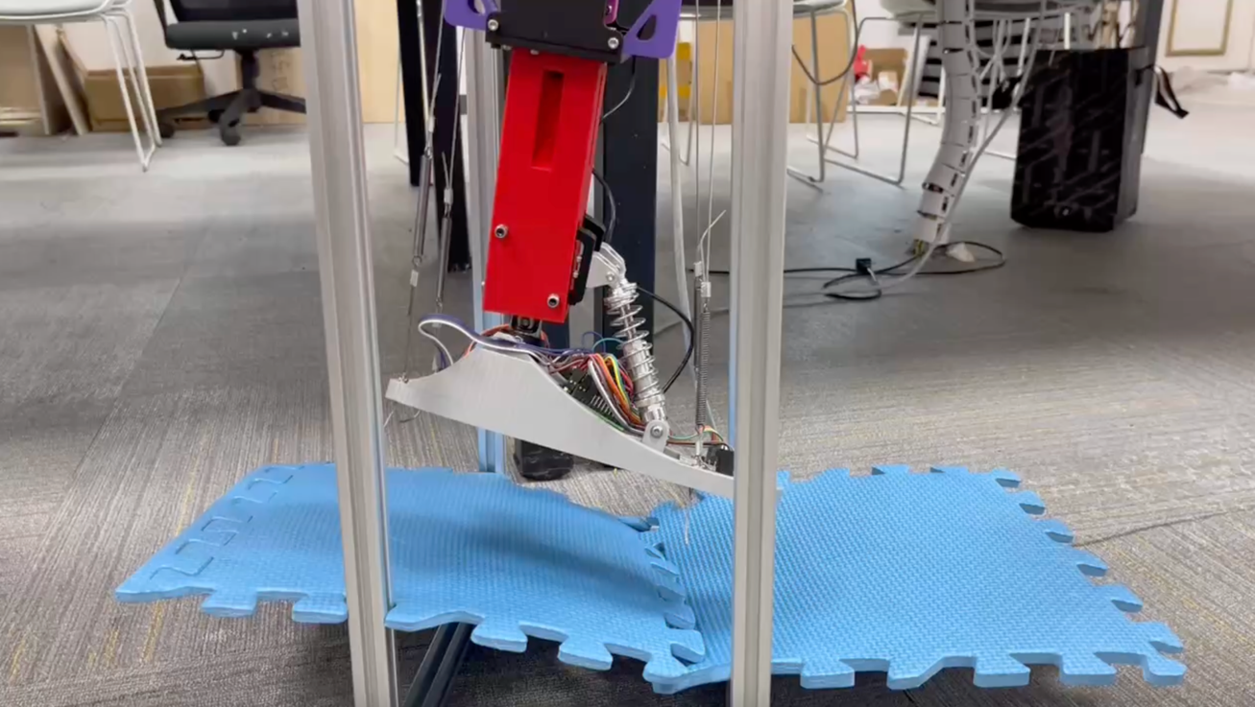
Today, I started up fixing the ankle, as it broke on last week’s experiment. Then, I continued to film the performance of the bionic ankle with multiple angles. It took not long, so I quickly ended the experinment and all was done.

